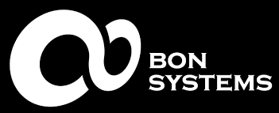
Bonsystems Co., Ltd. is helping product development based on a consortium with domestic and foreign manufacturers with excellent technology.
The consulting-based ONE on ONE customized product development service which Bon-systems boasts, is a system in which development experience and know-how accumulated during development projects are integrated in our product and service delivery.
We have worked with Kakao IX, Boram Sangjo, Crown Confectionery, OCI, and Korea Aerospace Industries and many more. We have also provided assistance to a number of companies engaged in the manufacturing industry, such as KAI.
The first condition to secure market competitiveness among overflowing products is “reduction of manufacturing cost” . In addition to systematic and strategic development direction and process design, we promise to add value to your product by incorporating Bonsystems' own system.
Business Areas | Product design, mechanism design, prototype production, mock-up production, product production, reducer
certification | ISO9001, company-affiliated research institute, venture company, design company,  certification of excellent technology company (T-3), selection of Changwon Shaped Small Giant Company,  Innobiz, Main Biz
email | bonsystems@naver.com
phone call | 055-552-1562
Patent | Conjugated double cycloid tooth reducer with helix angle (10-2015-0131755)
Patent | Pellet type raw material extruder (10-2017-0044165/10-2017-0044166)
 | Ceramic raw material extruder (10-2017-0144353)
 | BLDC motor with cooling part (10-2017-0039094)
 | Roller Track Gear System (10-2012-0040194)
 | Ultrasonic Motor (10-2013-0059237)

